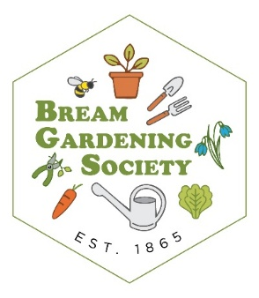 with 
FREE Workshops for Young Gardeners

2026
Activities at West Dean Centre and Bream Community Library –
for primary children and above

Thursday 19th February  2.00 – 4.00pm  * West Dean Centre, Bream GL15 6JW | Tomatoes – sowing, growing, tasting, all things tomato

Places are limited so……. Booking is essential
To join in - email breamgardeningsociety@gmail.com Remember to tell us your name and age

